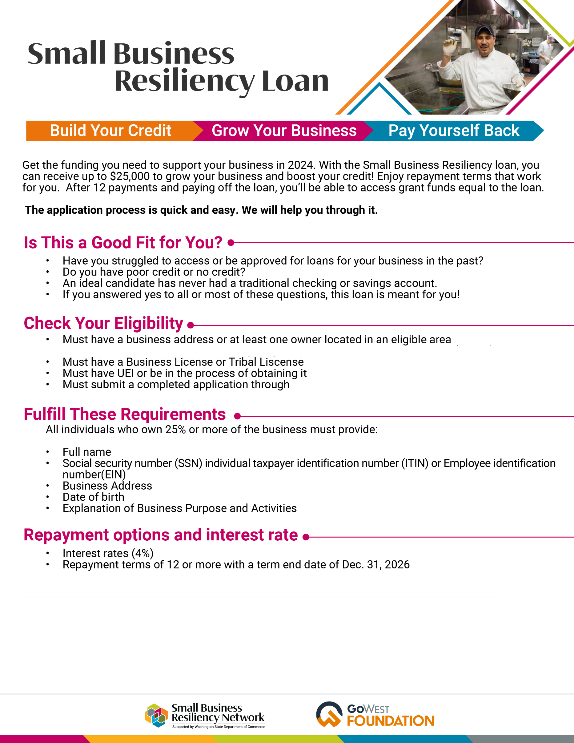

Your Organization Name

Your Organization Phone

Your Organization Email Address

PUT YOUR LOGO HERE

(SBRN Partner Name can check the business address in the eligibility tool)

Connect with SBRN PARTNER NAME to see if you qualify and submit your application.